Master Control Programs Site Plan

Spencer T. Crosland

Overview

Purpose
A site to display all my personal and professional projects to future clients or employers. The goal is to show present my skills for hire.

Audience
Clients and employers who may be interested in my projects or services I can provide.
Branding
Website Logo


Style Guide

Color Palette
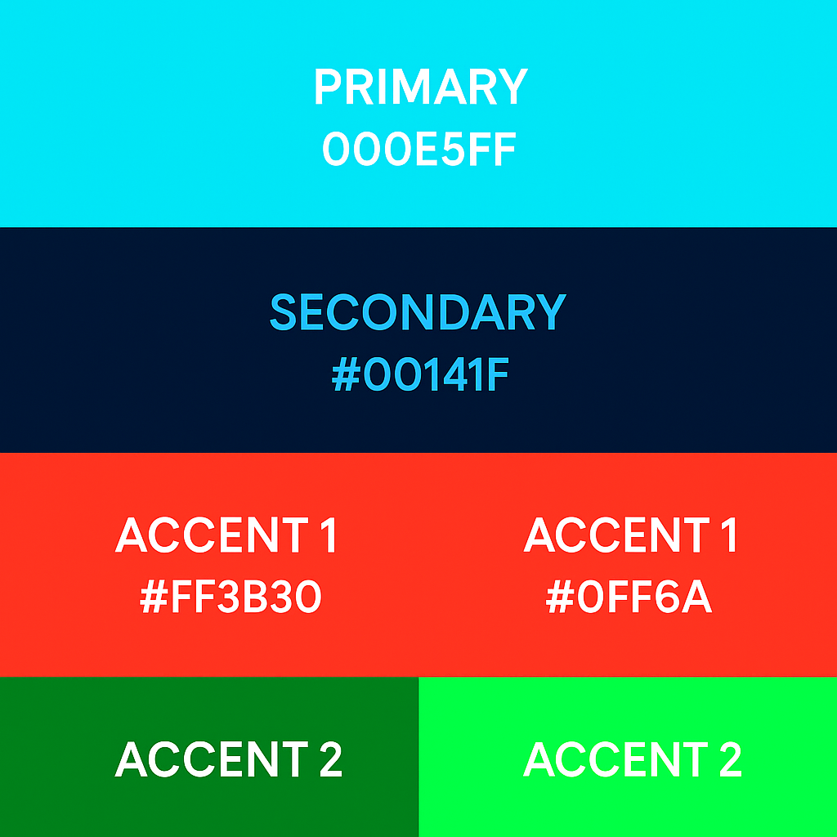

Typography

Heading Font: BBH Sans Bartle

Paragraph Font: Jura

Navigation
Home About Us Games Contact Us

Content

Header

